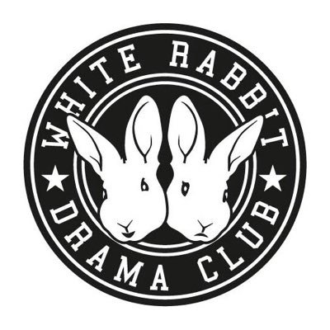
T-shirt and varsity jacket
order form
Please indicate in boxes below your order preferences:
White rabbit (WRDC) T-Shirt: Early bird offer: £8.50 each!
Usual price: 1 T-shirt: £11 each, 2+ T-shirts: £9.50 each
- Size 1st T-shirt 2nd T-shirt
- XS (3-4 years)
  - S (5-6 years)
  - M (7-8 years)
  - L (9-11 years)
- Colour
- Black
- Green
- Purple
- Logo
- White
- Glitter

WRDC Varsity Jacket: Early bird offer: £19.50 each!
Usual Price: 1 Jacket: £23, 2+ Jackets: £21
- Size 1st Jacket 2nd Jacket
- XS (3-4 years)
  - S (5-6 years)
  - M (7-8 years)
  - L (9-11 years)
- Colour
- Black
- Purple
- Logo
- White
- Glitter

Please note, we can only process your order once full payment has been received. Orders take roughly 2 weeks to arrive.
Child’s name: ___________________________________________________
Date: __________________________________________________________
Amount paid: ___________________________________________________

